ACSL
American Computer Science League
2013 - 2014

Contest #3

Classroom Division Solutions Page 2

6. Graph Theory
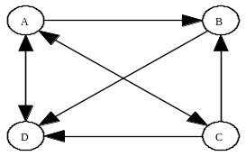

6. As shown
0 | 1 | 1 | 1
0 | 0 | 0 | 1
1 | 1 | 0 | 1
1 | 0 | 0 | 0

7. 23
7. Graph Theory

0 | 1 | 0 | 1 | 0 | 2 |  | 0 | 1 | 1 | 2 | 1
0 | 0 | 1 | 1 | 0 |  |  | 0 | 2 | 0 | 2 | 1
0 | 1 | 0 | 1 | 0 |  | = | 0 | 1 | 1 | 2 | 1
0 | 1 | 0 | 1 | 1 |  |  | 1 | 1 | 1 | 2 | 1
1 | 0 | 0 | 0 | 0 |  |  | 0 | 1 | 0 | 1 | 0

Squaring an adjacency matrix produces all paths of length 2.
Adding the entries gives the paths of length 2.

8. (0, 1, 0)
(1, 0, 1)
8. Boolean Algebra
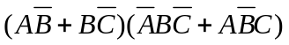=
==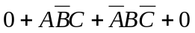= 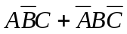
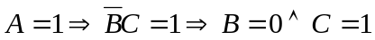 and 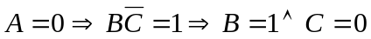
Therefore (1, 0, 1) and (0, 1, 0) make it true.

9. Boolean Algebra
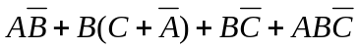=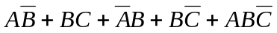
= 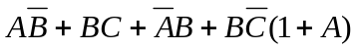 = 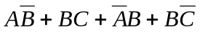
= 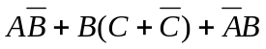 =
So 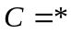 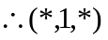
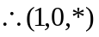

9. 6
10. What Does This Program Do?
This program changes all negative entries to 0, then replaces all the even entries by the result of dividing by 2, and finally makes all the entries less than 3 equal to 0. That leaves 3 that are not 0.
Original: -1 0 1 2 Final: 0 0 0 0
-2 0 2 4 0 0 0 0
-3 0 3 6 0 0 3 3
-4 0 4 8 0 0 0 4
10. 3

